Modeling Soil Chemical and Physical Properties in the Southeastern US

The goal of this analysis is to take soil horizon-based NRCS measurements of soil chemical (total carbon, organic carbon, phosphorous, potassium, calcium, magnesium, pH, total base cations) and physical (bulk density and soil texture) properties and model these depth-horizon based values for each soil type found within the extent of all USDA Forest Service Experimental Forests and Ranges (EFR) found in the southeastern US.

Bulk Density Model  
  
First, a soil bulk density model was created from 1,199 soil bulk density values derived from 286 pedons from 149 different soil series. Bulk density measurements were made at the soil horizon level, with the depth of soil horizons varying among pedons. To calculate soil bulk density by soil depth (0 -10, 10 - 20, 20-40, 40-100), we first calculated the midpoint depth of each measured horizon. We then assigned each measurement to a depth horizon based on midpoint depth. We then calculated the soil bulk density of each depth horizon, for each soil series as the mean of all soil bulk density values in that horizon for that soil series. For those without bulk density, a global average of the bulk density for that layer for the whole data set was substituted.

Soil Chemistry Models

We modelled soil calcium, magnesium, potassium, total carbon, total nitrogen, organic carbon,  phosphorus, using negative exponential models fit to lab-measured values. Soil chemistry data where calculated at the soil horizon level, the same as soil bulk density above. The same approach of calculating a horizon midpoint depth was used. Horizon midpoint depths were used to derive model coefficients  at the soil series level using the following equation:

C (g m^-3) = b0 * exp( -b1 * horizon_midpoint)

Make a note of threshold removal.

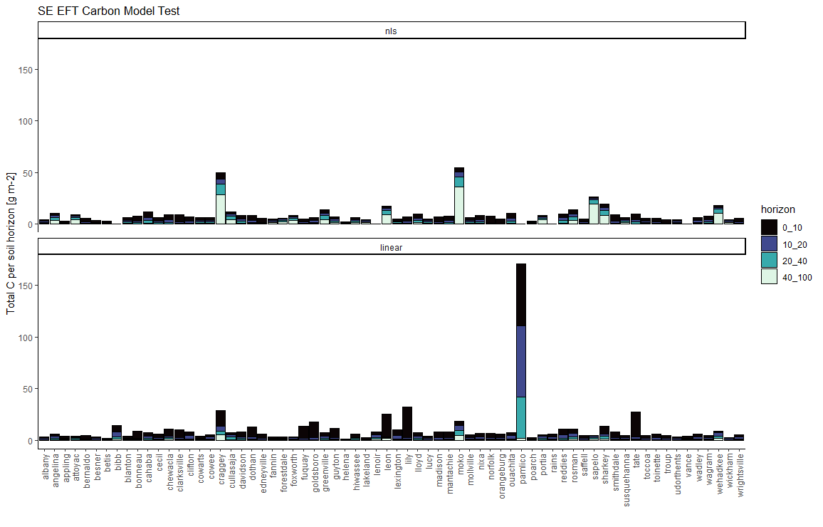  
  
  
  
  
  
Notes on units:

Bulk Density Oven dry methods

4A1h and Db – reported to the nearest 0.01g cc-1 of <2-mm soil fabric

 Particle size methods

Reported in %

4D - Phosphorus reported as % to the nearest hundredth

6S3 – phosphorus reported as % to the nearest whole number

Walkley-Black Method

6A – report % at 2 decimal places, on an oven-dry basis

6A1a - % on ovendry basis

6A2d - % on oven dry basis to nearest 0.1%

Total nitrogen

All methods - report total N as a dimensionless value to the nearest 0.001 unit on an ovendry basis.

Total Carbon

% on oven dry basis

Ca_nH4_ph_7_method, K_nh4_ph_7_method and mg_nh4_ph_7_method

4B1a – moisture content as a percentage of <2-mm. report procedure code 4B1a and the equilibrium tension

6N2, 6O2, and 6Q2 – report the extractable Ca, K and Mg in units of meq 100g-1 of oven dry soil to the nearest 0.1 meq 100g-1